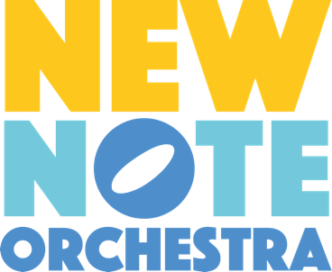

HOW TO APPLY:
We will need two things from you:
- A video of you playing at least one instrument. Please make the video no longer than 10 minutes.
- To answer four questions on the form below.
For the video:
- You don’t need to be able to read music but some musical confidence goes a long way. Show us how you might use your musical skills. We are looking to see how your skills can be used in group settings. If you are an electronic artist, please send in some of your work and a video explaining how you use the equipment.
- If you are a singer please demonstrate your vocal abilities.
For the form:
You will need to fill in this form and answer all four questions. There is no word count, take as much space as you need to tell us about yourself.
If you are unable to fill in the form, please get in touch Keychangersprog@gmail.com where we can offer an alternative.
Send your video and application to: Keychangersprog@gmail.com

Name:

Date of Birth:

Address:

- Why do you want to be on the Key Changers Programme?
- Give us an overview of who you are and why you want this opportunity
Answer question 1 here:

- What can you bring to the Key Changers Programme?
- We would like to get to know you better so tell us about your skills.
- We need to know why we should offer you a place
Answer question 2 here:

- What would you like to get out of being on the programme?
- Tell us about your ambition for being trained as a community music leader
- How would you benefit if we offered you a place?
Answer question 3 here:

- We are interested to hear from marginalised people who want to develop their musical skills. Please tell us about why you are marginalised and what support you have in place. This could include: Recovery from addiction, managing a mental health condition, having refugee status.

Answer question 4 here:

